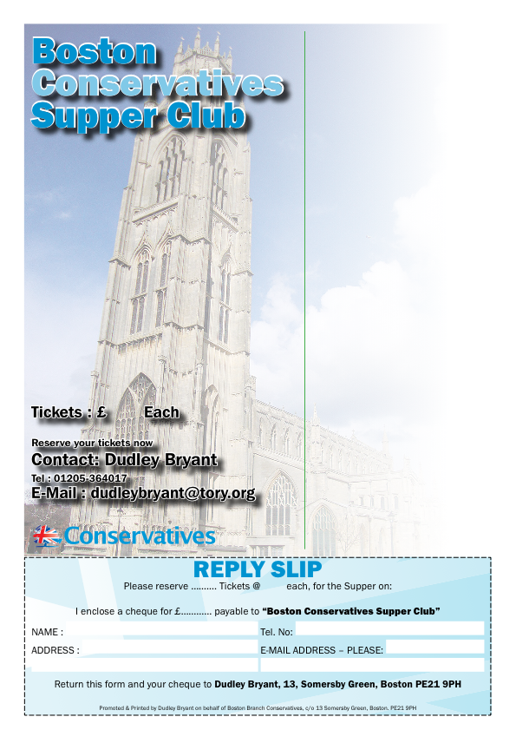
You and your friends are invited to
SUPPER CLUB
FRIDAY
18TH NOVEMBER 2016
at 7.30pm
To be held at
Boston & County Club
Parkgate, Boston PE21 6RL
RSVP by Friday 11th November 2016
Guest Speaker
Andrew LewerMBE MEP
East Midlands Conservative Member of European Parliament
………
Supper Menu
Roast Beef & Yorkshire Pudding;
Chocolate Sponge; Coffee & Mints.
Forthcoming Events Supper Clubs
20 Jan. 2017 Matt Warman MP Member of Parliament for Boston & Skegness
17 March 2017 Cllr. Martin Hill OBE
Leader of Lincolnshire County Council

FRIDAY 18TH NOVEMBER 2016
BOOK EARLY / RSVP by Friday, 11TH NOVEMBERT 2016
£12.50
12.50

