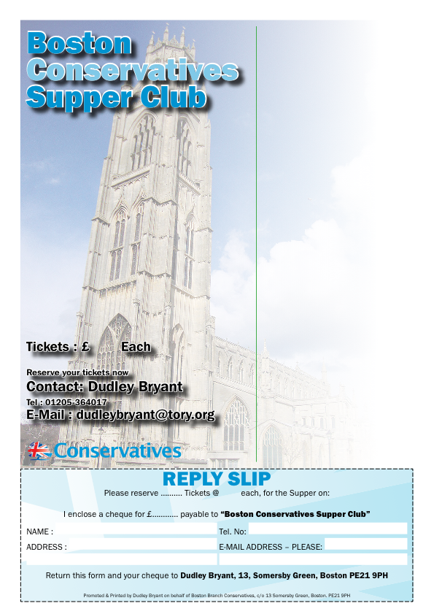
You and your friends are invited to
SUPPER CLUB
FRIDAY
21st SEPTEMBER 2018
at 7.30pm
To be held at
Boston & County Club
Parkgate, Boston PE21 6RL
RSVP by Friday 14th September 2018
Invited Guest Speaker
Group Captain Mike Baulkwill Station Commander RAF Coningsby
………
Supper Menu
Roast Lamb on a bed of Rosemary Mash; Meringue nest with Raspberries; Coffee & Mints
Forthcoming Events Supper Clubs
16 Nov 2018 Rt. Hon. John Whittingdale MP Member of Parliament for Maldon, Essex. Member of Committee on Exiting EU

FRIDAY 21 SEPTEMBER 2018
BOOK EARLY / RSVP by Friday, 14TH SEPTEMBER 2018
£15.00
15.00

